**MongoDB Practice Test**

Creating Database Commands:

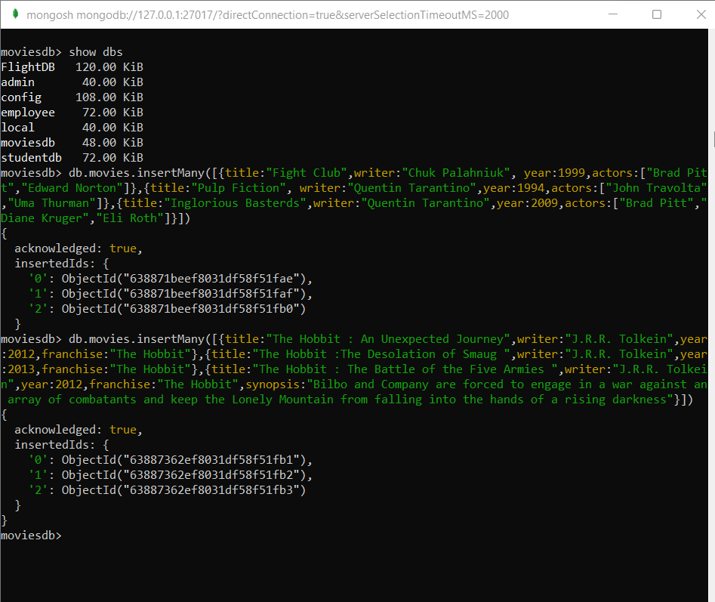

1:- get all documents

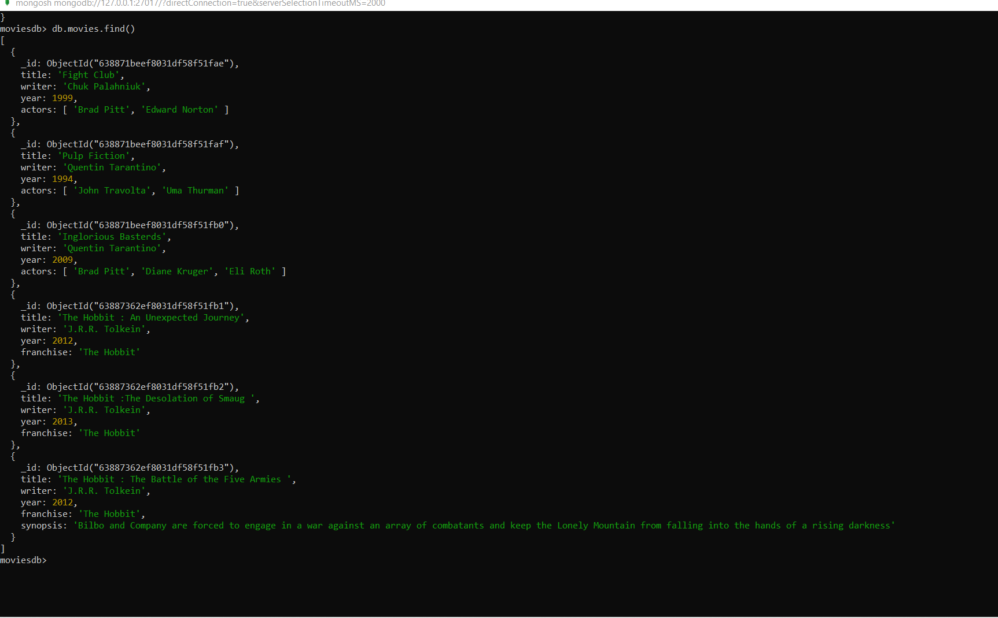

2:- get all documents with writer set to "Quentin Tarantino"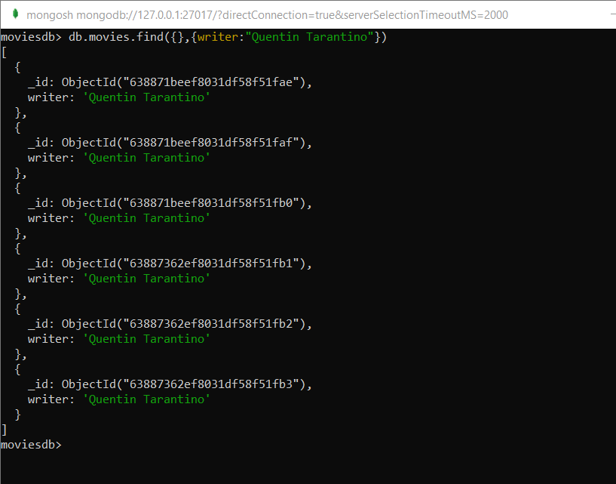

3:- get all documents where actors include "Brad Pitt"

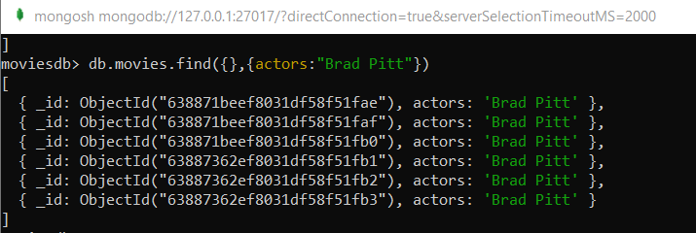

4:- get all documents with franchise set to "The Hobbit"

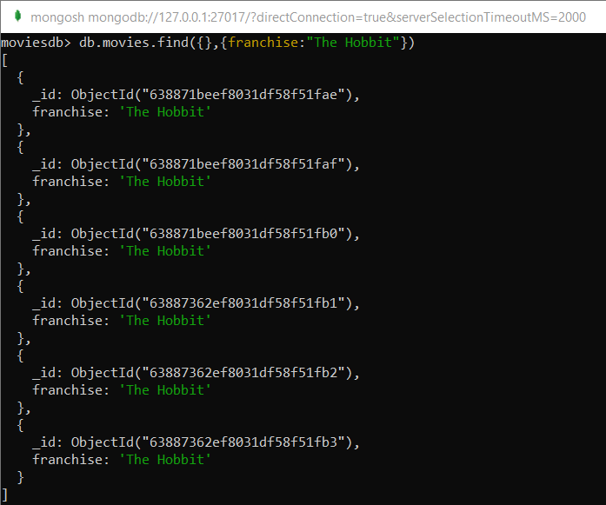

5:- get all movies released in the 90s

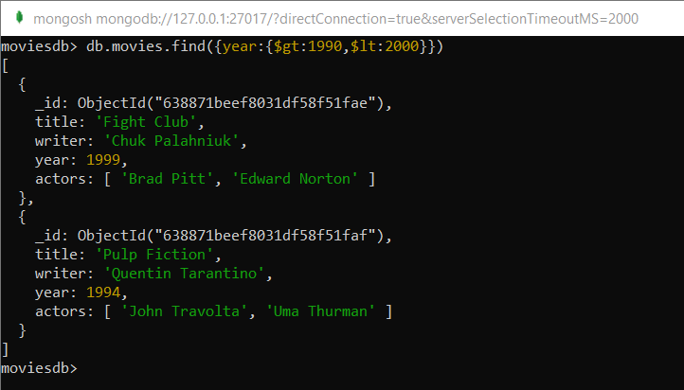

6:- get all movies released before the year 2000 or after 2010

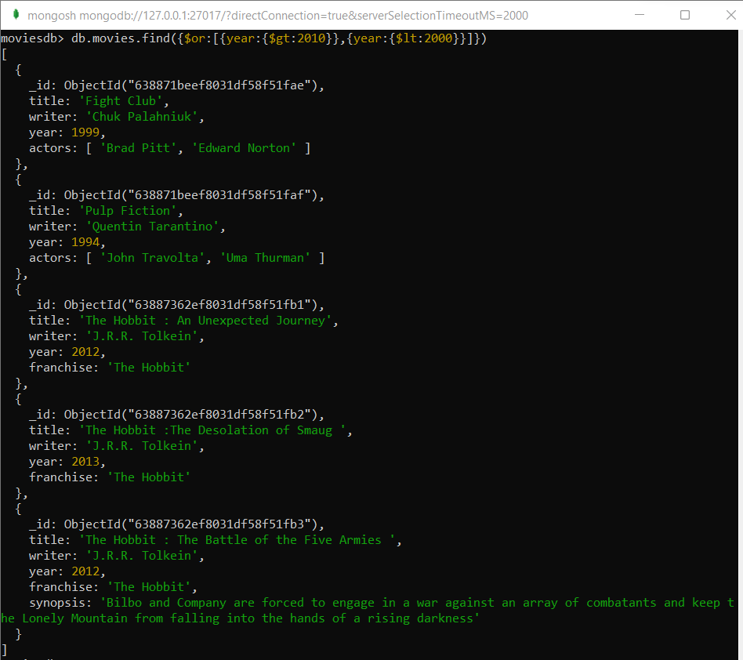

7:- count the number of writer from the movie collection

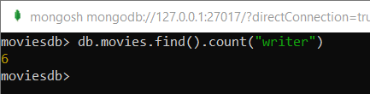

8:- update an actor named "Samuel L. Jackson" to the movie "Pulp Fiction"

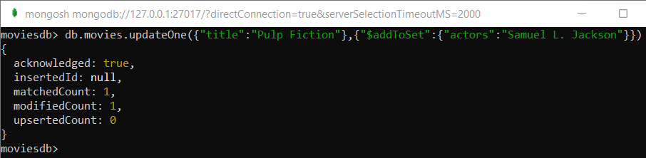

9:- find all movies that have a synopsis that contains the word "Gandalf"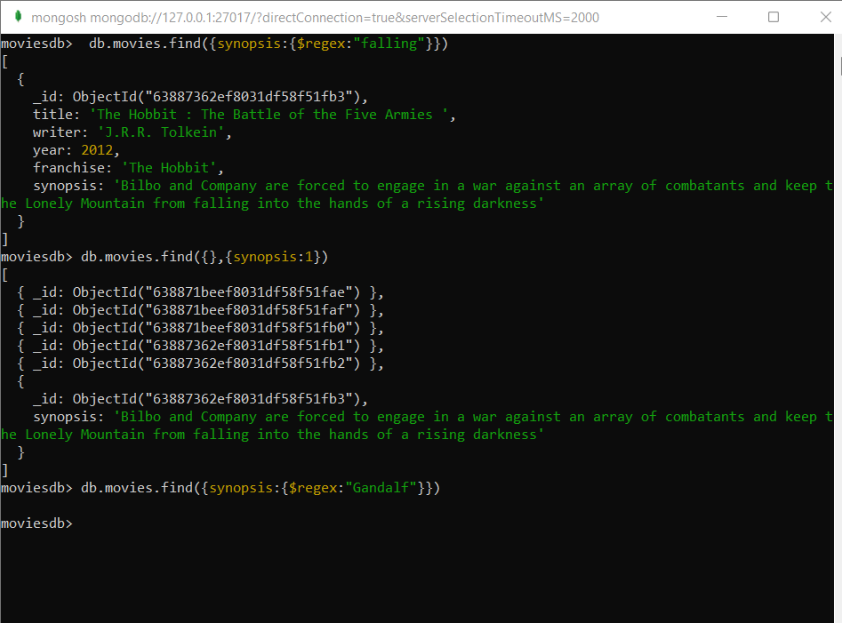

10:- display the movie collection based on year in descending order.

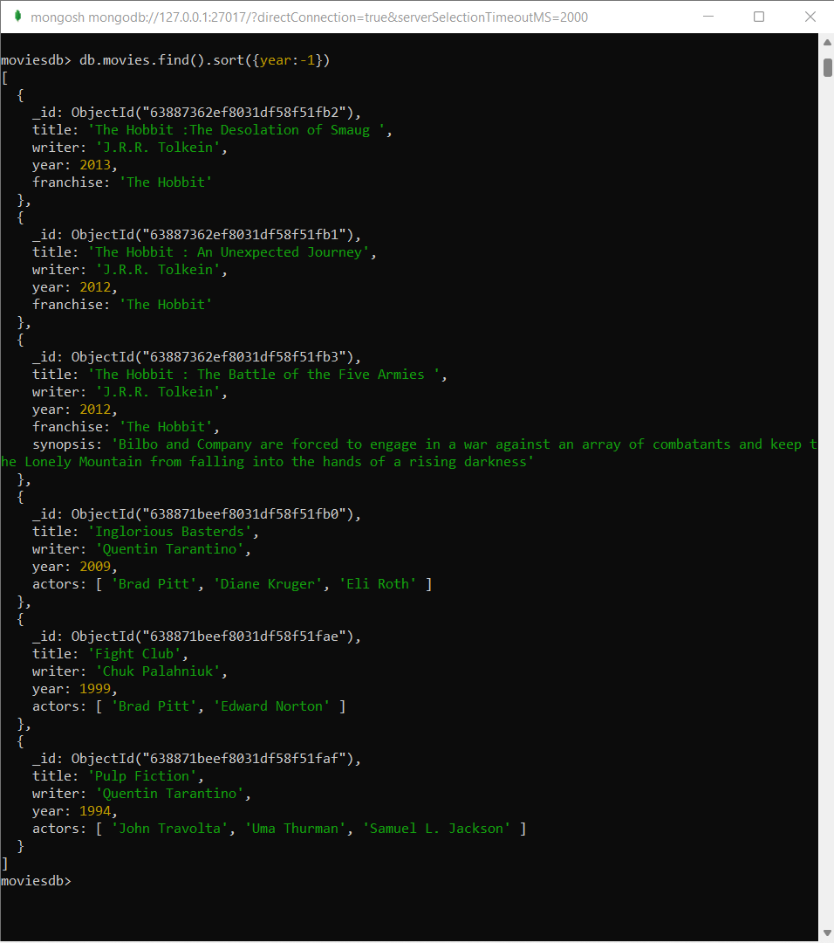

11:- Display last two recent movie.

